**Back-End Operation**

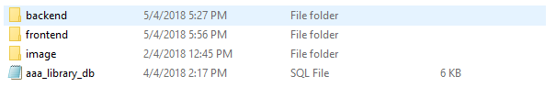First of all, to run this web application with some sample in the database, we must to import the aaa_library_db.sql file into MySQL the folder located as below:

Go to the backend web pages use the url as below:

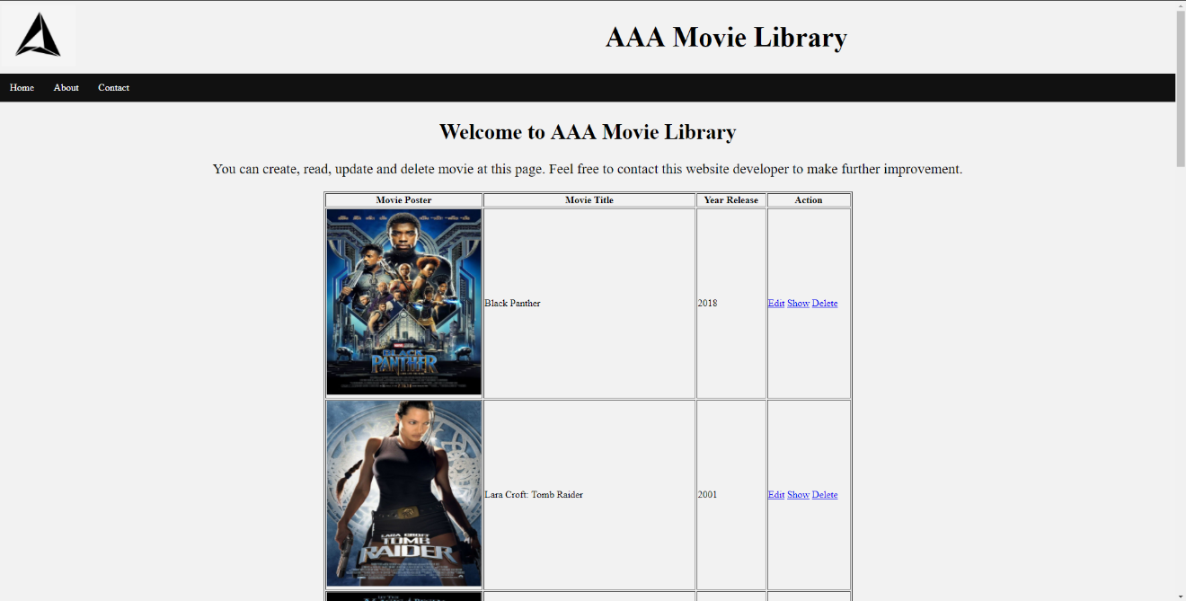And the Homepage will be like this:

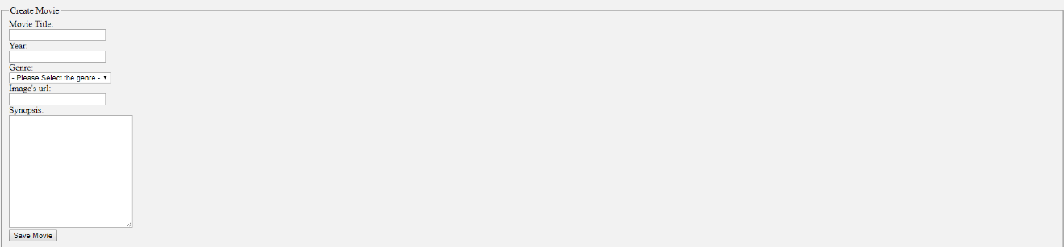To create a movie, we scroll down to the bottom of Homepage and by using this form:

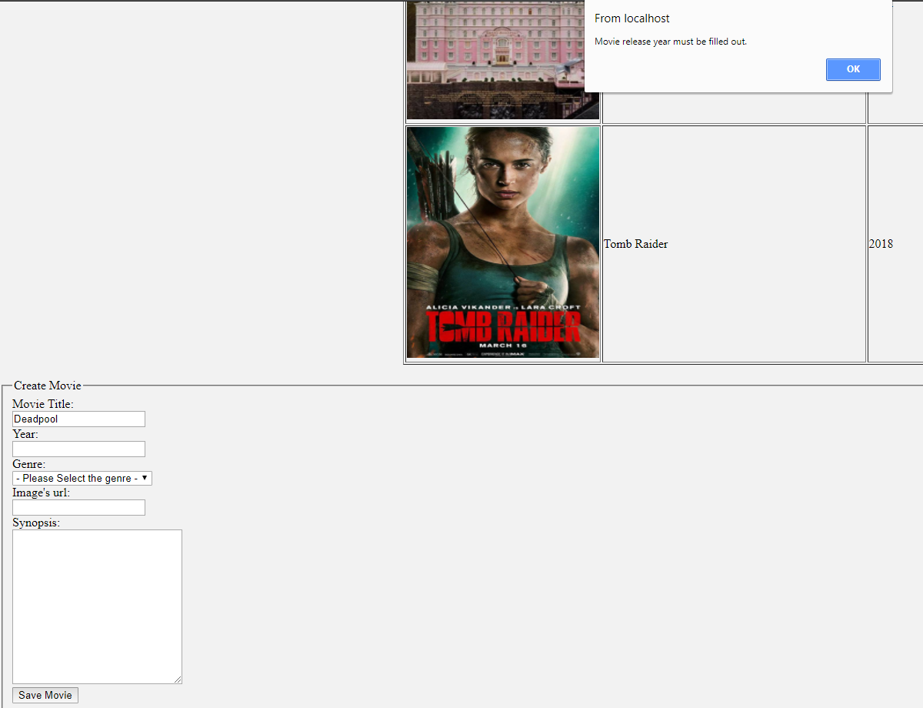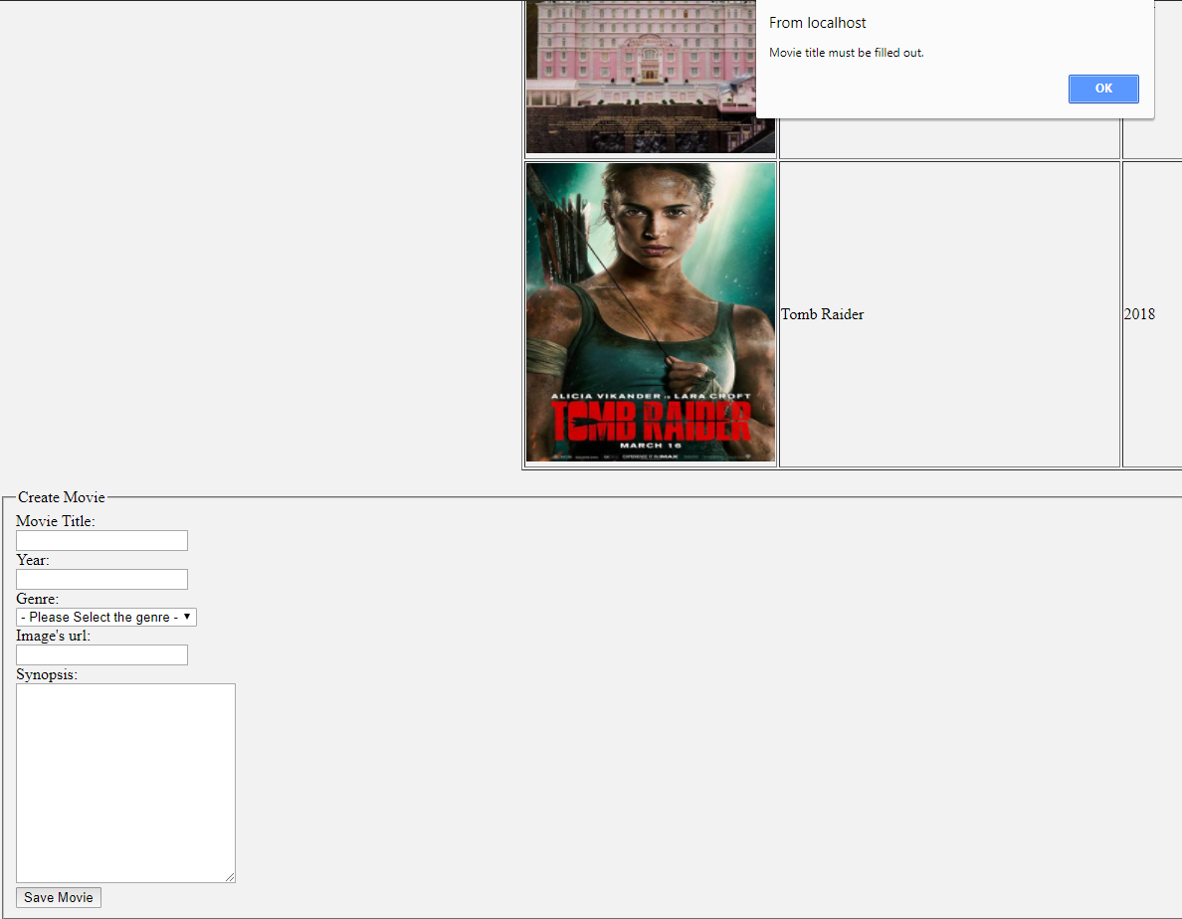And of course, there is a form validation for this form element, synopsis is nullable for my case, therefore, there are empty validation for all other field except synopsis:

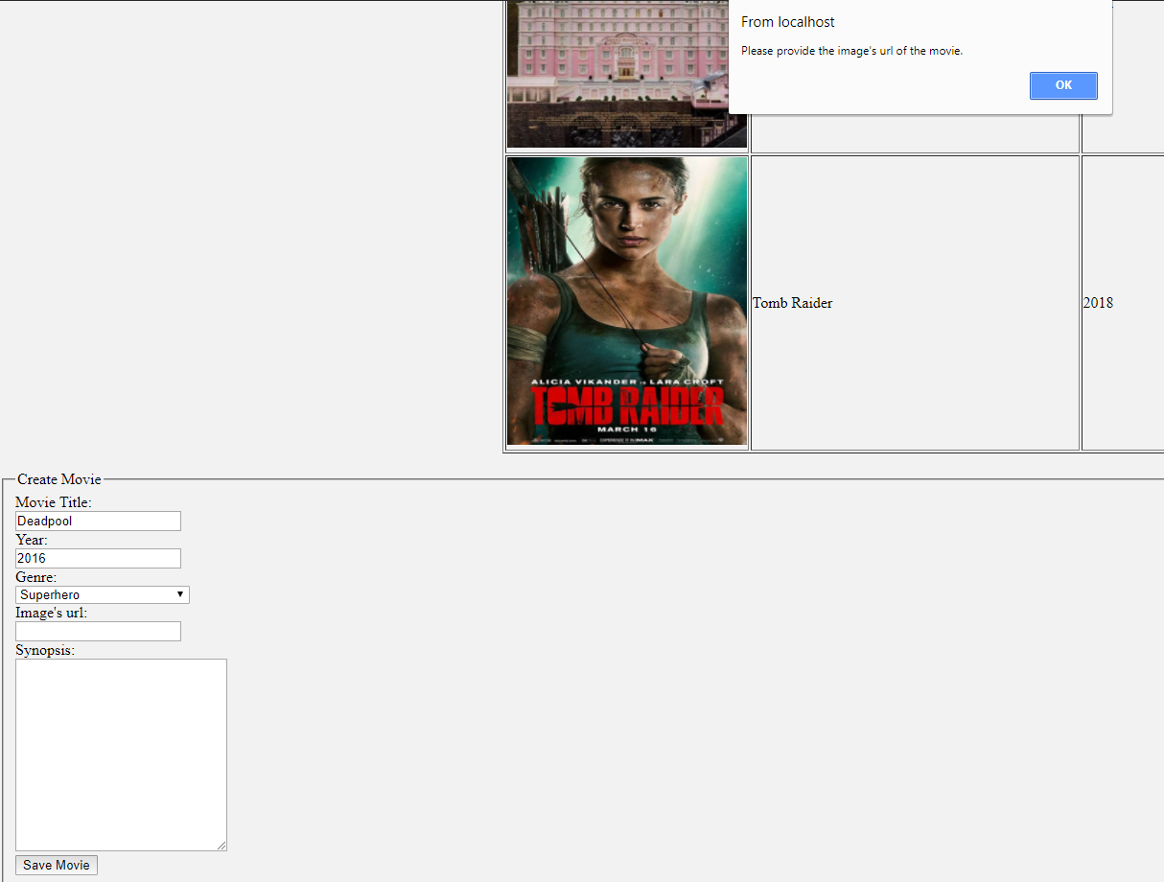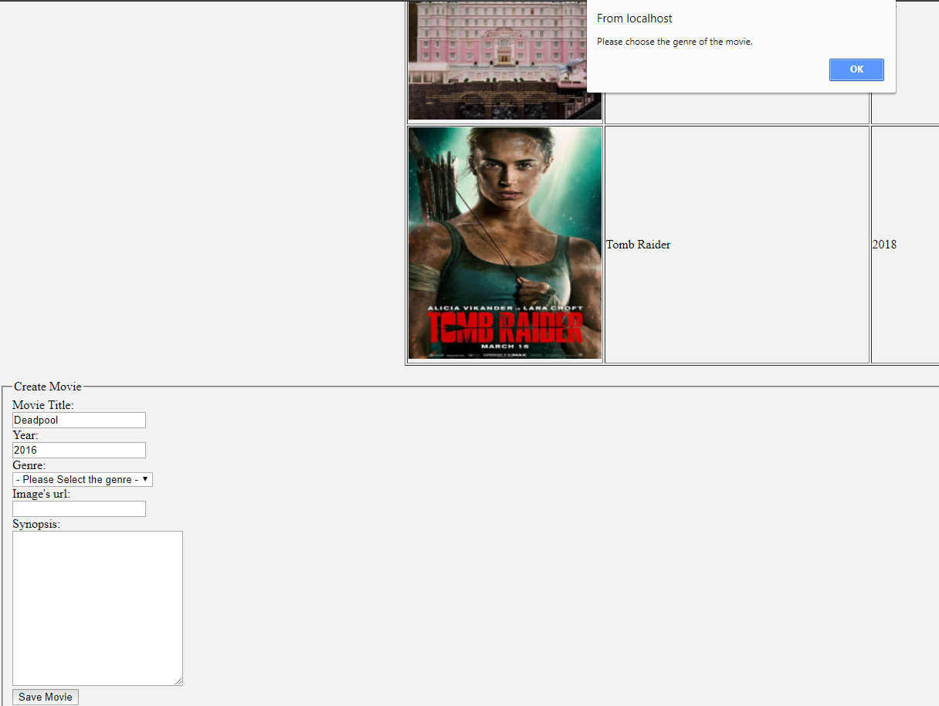

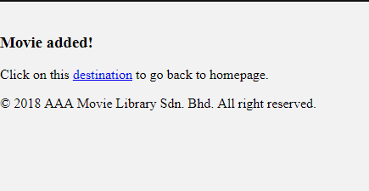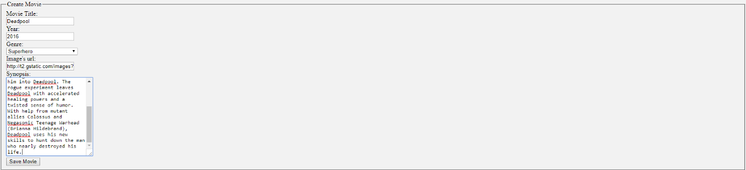After the form was filled, press Save Movie button and this will redirect to another page, and there is a link to click to go back the Homepage:

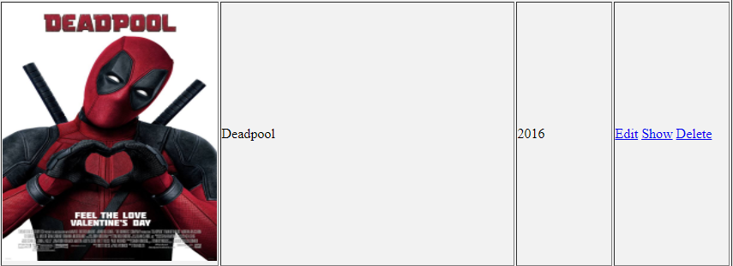We can see the movie’s detail by clicking the Show, edit the movie’s details by clicking Edit and delete the movies from the database by clicking Delete in the Action column for certain movie:

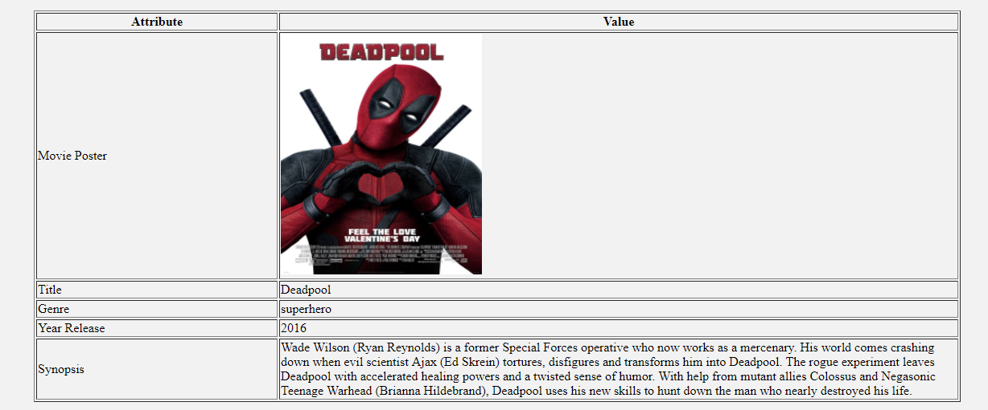Show, Edit and Delete:

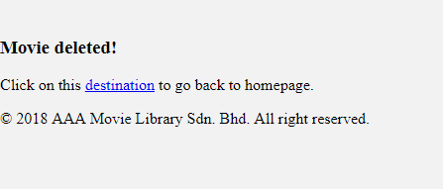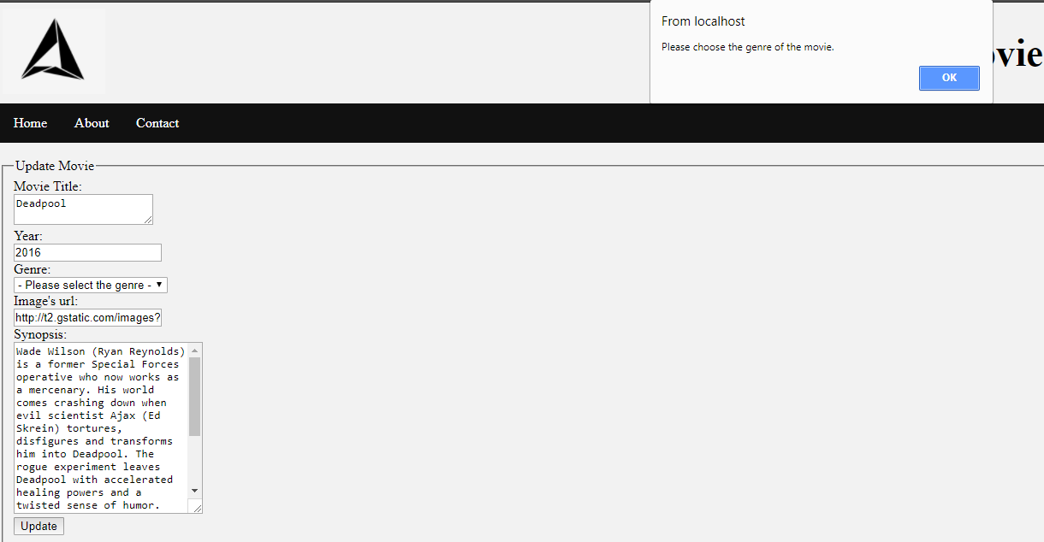There are form validation for edit form too:

**Front-End Operation**

Go to the frontend web page using the following url:

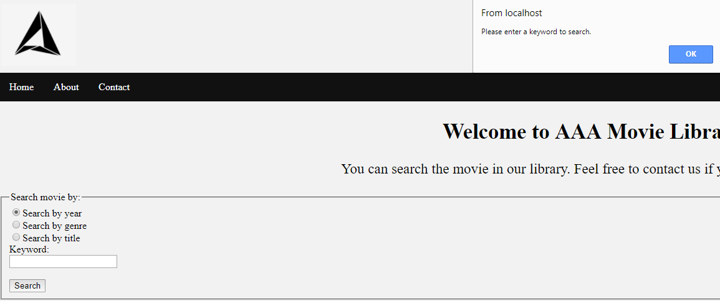User can search the movies by year, genre or title, and there is form validation for the keyword field and it must not be blank:

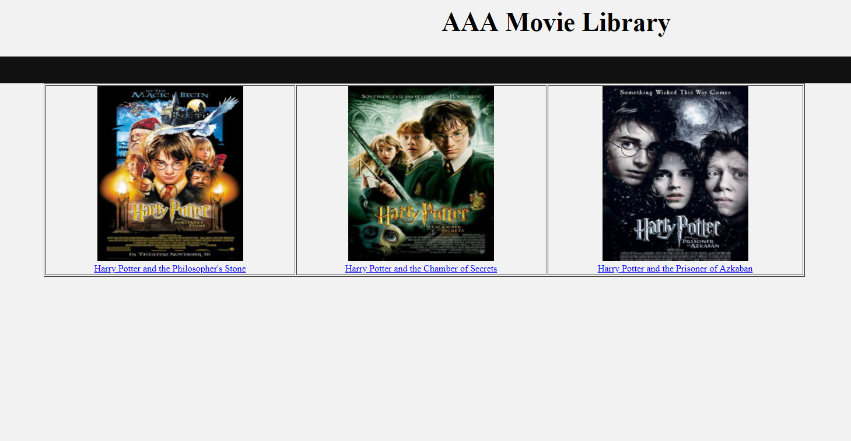Search by keyword ‘harry’:

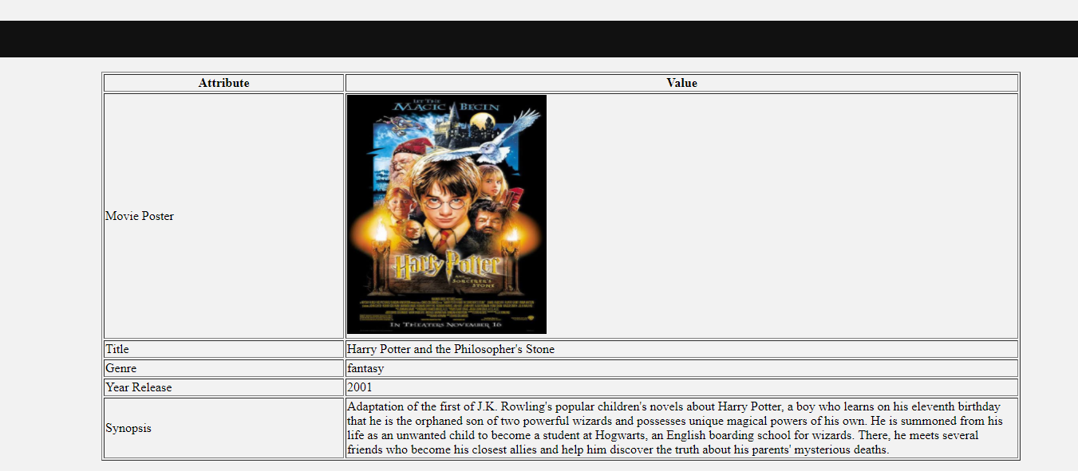By clicking the poster or movie’s title, it will bring the user to the details of movie web page to allow them check on the movie: